Project title: Peat-forming seasonally flooded forests of the Peruvian Amazon: distribution, carbon storage, and long-term ecology
School of Geography and Sustainable Development, University of St Andrews
Supervisory team: Dr Ian Lawson, Dr Katy Roucoux (St Andrews), Dr Euridice Honorio (RBG Kew), Dr Pauline Gulliver (SUERC/U. Glasgow)
Broad topic areas: Quantitative data analysis in environmental geography; Remote sensing for environmental and social justice
Category: PhD Geography (Science) / Edwards competition
Right: Core sample from a peatland in Peruvian Amazonia, showing the transition from mineral sediment to peat. | 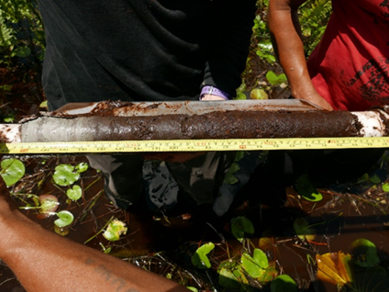

Outline of the proposed research area
The overall aim of this project is to investigate, for the first time, the distribution, carbon storage, and long-term ecology of peat-forming seasonally flooded forests in Peruvian Amazonia.
Among the most important discoveries about the global carbon cycle over the past few years is that, in the Amazon and Congo basins, huge amounts of carbon are stored below ground, hidden from view, in the form of peat – partly decomposed plant litter. It was once thought that peat could only form under exceptional circumstances in the lowland tropics, because organic matter typically decomposes very quickly in hot, humid environments, but it is now clear that many, perhaps most, permanently waterlogged locations in the landscape are suitable for peat formation. The discovery of such widespread peatlands has generated a lot of research activity aimed at trying to understand just how much carbon is stored in the peat, where that peat occurs, and how vulnerable it is to human disturbance and future climatic change. One of the key geographical areas where that research is taking place is the Pastaza-Marañón Basin in Peru. Our group’s work has helped to show that this one part of Peruvian Amazonia, approximately half the area of the UK, contains about 35,000 km² of peatlands storing over 5 billion tonnes of carbon (Hastie et al. 2022), more than half as much again as the total amount of carbon stored in UK peatlands. In places the peat reaches 6 m thick and is up to 8,000 years old.
For more than a decade, our team has been mapping the peatlands using increasingly refined techniques, describing the peatland vegetation, measuring other ecosystem properties such as water table change and peat chemistry, and using pollen analysis and other palaeoecological techniques to understand how the ecosystems change through time. We are also working with local communities, including indigenous groups, to explore their understanding of the ecosystems within which they live and integrate that knowledge with our more science-based results. Gradually, we are piecing together a picture of how the complex wetland landscapes of the Pastaza-Marañón basin are structured, and how that structure changes over centuries to millennia. The focus of this project is on one of the missing pieces in the jigsaw: seasonally flooded forests.
Seasonally flooded forests occur widely on the floodplains of Amazonian rivers which, responding to seasonal cycles of precipitation and Andean meltwater, can fluctuate in level by several metres. For large parts of the year the forests are under a metre or more of water. Consequently, they are dominated by tree species which can tolerate long periods of flooding, but despite what might seem to be adverse conditions, some seasonally flooded forests are very productive – fertilized by annual deposition of river silts – and can have a tall canopy with substantial trees. As the name implies, in all seasonally flooded forests the period during which the water level is above the ground surface only lasts for part of the year. In many cases the water table drops well below the surface during the low-water season, which allows oxygen to enter the soil, accelerating the
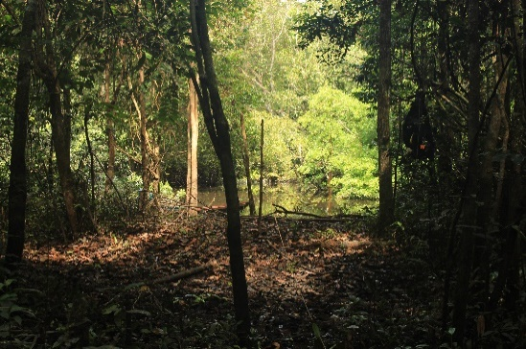 | Left: Seasonally flooded forest, Peru.
decomposition of plant matter – hence many seasonally flooded forests do not form peat. However, we know that some do, if the water table does not drop far below the surface.
The fact that some seasonally flooded forests form peat may have important implications for our understanding of peat carbon storage on a continental scale. Some studies (e.g. Gumbricht et al. 2017: see Hastie et al. 2024) predict that peat should be very widespread on the floodplains of the Amazon under seasonally flooded forest. Other studies (e.g. Draper et al. 2014), based on limited field measurements, suggest that peat should be absent or rare under seasonally flooded forest. Yet we know for a fact that some seasonally flooded forests do hold peat. In fact, it is possible many peatlands might pass through a successional stage that could be described as seasonally flooded forest.

Aims and research questions
The aim of this project is to explore the formation of peat in seasonally flooded forests. In particular, the project will address the following research questions:
RQ1. What are the geomorphological and hydrological conditions required to promote peat accumulation in seasonally flooded forests?
RQ2. How much soil carbon is stored in the seasonally flooded forests of the Pastaza-Marañón Basin?
RQ3. How old are peat forming seasonally flooded forests compared to other peat forming ecosystem types?
RQ4. Is seasonally flooded forest a common stage in the vegetation succession of peat swamps in the region?

Objectives and methodologies
RQ1: The project will test two alternative hypotheses: (1) that site geomorphology (e.g. the presence/absence of a bund or levee) controls the local hydrological conditions (i.e. persistent waterlogging of soils) that promote peat accumulation; (2) that local site geomorphology is unimportant, but instead the presence of peat in seasonally flooded forest can be predicted using our group’s existing remote-sensing-derived models of peat distribution and hydroperiod. The student will select field sites aimed at testing these hypotheses, visit the sites, and survey flooding regime, water table depth, peat thickness, and surface topography.
RQ2 & RQ3: The student will collect peat and sediment samples from each study site and analyse their carbon content and bulk density. (Even at sites where there is no peat, rates and quantities of carbon burial in sediment are of interest.) The student will apply radiocarbon dating to selected samples to assess the timing and rate of carbon accumulation. Existing models of peat and vegetation distribution may be used to extrapolate these results to a larger spatial scale.
RQ4: The student will use pollen analysis (and possibly other selected palaeoenvironmental techniques) to analyse (i) surface samples from the study sites, and (ii) the changes in pollen assemblages down-core (at one or more sites where peat occurs). Using the results from the surface samples, the student will also reanalyse existing pollen data from peat swamps in the region to better understand the place of seasonally flooded forests in peatland vegetation succession.
Project outputs will include the thesis and journal articles. The student will also be encouraged to use their results to inform policymakers and other stakeholders.
References/further reading
- Draper et al. (2014) https://iopscience.iop.org/article/10.1088/1748-9326/9/12/124017
- Roucoux et al. (2017) https://conbio.onlinelibrary.wiley.com/doi/full/10.1111/cobi.12925
- Hastie et al. (2022) https://www.nature.com/articles/s41561-022-00923-4
- Hastie et al. (2024) https://iopscience.iop.org/article/10.1088/1748-9326/ad677b

